Project Design Phase Solution Architecture

Date | 08/11/ 2025
Team ID | NM2025TMID02958
Project Name | Garage Management system
Maximum Marks | 4 Marks

Garage Management System - Project Design Phase

Project Design Phase
The Project Design Phase defines the system's operational structure, data organization, user interface design, and flow of information. This phase ensures that the system is built in a structured and efficient manner, making it easy to use, maintain, and scale.

System Architecture
The system follows a three-tier architecture:
+------------------+ +---------------------+
| User Interface | <----> | Application Layer |
+------------------+ +---------------------+
| v
+------------------+
| Database Layer |
+------------------+

Description
- User Interface (UI): Screens where data is entered, viewed, and updated.
- Application Layer: Contains logic for handling service jobs, billing, and inventory updates.
- Database Layer: Stores customer, vehicle, mechanic, parts, and billing information.

ER Diagram (Conceptual Overview)
The Entity Relationship model illustrates how data is structured and connected.
Customer ----< Vehicle ----< ServiceJob ----< Invoice
| |
| v
| SpareParts

Entity Descriptions
Entity Description
Customer | Stores customer personal information
Vehicle | Stores vehicle details linked to customers
ServiceJob | Contains information about the job performed on the vehicle
SpareParts | Represents parts used during servicing
Invoice | Records billing information for the completed service

User Interface (UI) Design Overview
The UI is designed to be simple, user-friendly, and easy to navigate for garage staff.

Key Interface Screens
- Dashboard
- Displays total registered customers
- Shows number of ongoing service jobs
- Displays spare parts stock alerts
- Customer & Vehicle Registration Form
- Used to add new customer and their vehicle details
- Ensures each vehicle is linked to its owner
- Service Entry (Job Card) Screen
- Allows assigning mechanic and recording service tasks
- Tracks service progress and estimated delivery time
- Billing / Invoice Screen
- Automatically calculates cost of spare parts and labor charges
- Generates printable invoice for customer

Output of Design Phase
- System architecture finalized
- Database design structured with entity relations
- UI layout planned for efficient workflow
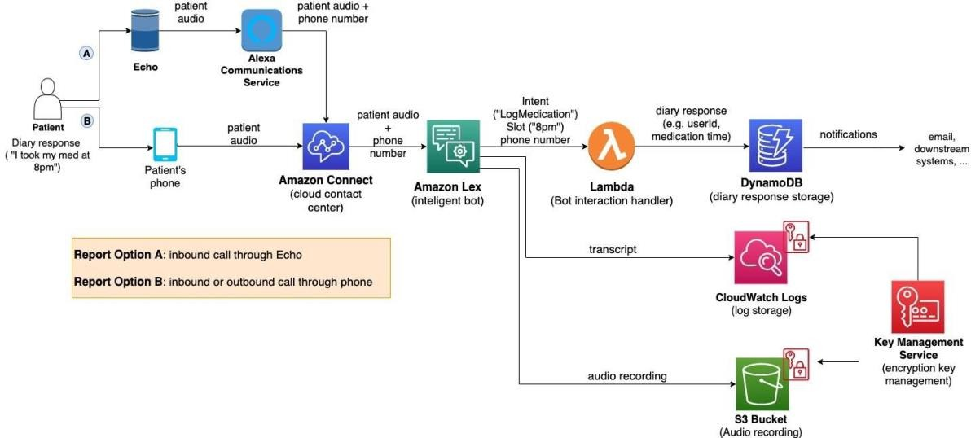
- Ready to move into development phase

